**Add- Category:-**

As a healthcare provider, I want to categorize messages based on their type,

So that I can sort different types of messages efficiently.

**Scenario 1: View Message Categories**

**Given:** The user is logged into the EHR system

**When:** The user navigates to the "Interface Hub"

**Then:** The user should see message for all selected categorizes such as  Laboratory, Radiology, Immunization, Demographics, Appointments, Superbill, Clinical and Documents  [See Attachment: **02.png**]

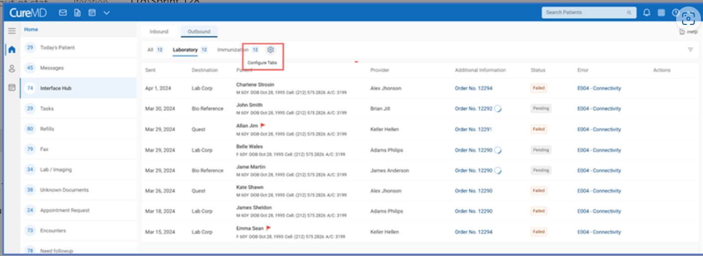

|  |  |
| --- | --- |
| Outbound | Message Type |
| Laboratory | Lab Order, Lab Results |
| Radiology | Radiology Order, Radiology Results |
| Immunization | Immunization, Query By Parameter |
| Appointment | Scheduling Trigger |
| Demographics | Patient Add, Patient Update |
| Superbill |  |
| Document |  |
| Clinical | PnR, Clinical Notes, Common Well, Api Gateway |
| Inbound |  |
| Laboratory |  |
| Radiology |  |
| Immunization | Immunization, Query By Parameter |
| Appointment | Scheduling Trigger |
| Demographics | Patient Add, Patient Update |
| Superbill |  |
| Document |  |
| Clinical | PnR, Clinical Notes, Common Well, Api Gateway |

**Scenario 2: Add Message Category**

**Given:** The user is logged into the EHR system

**When**: The user hovers on the Settings icon.

Then: System shall display "Customize Tabs" in Tooltip

**AND:**clicks ‘Customize Tabs’ icon[See Attachment: **01.png**]

**Then**: The user should see a list of all message categories

**And:** The user should be able to add, remove, or reorder (customize) the message tabs.

**Business Rules:**

* The system shall allow users to drag and drop categories within the dropdown list. The tabs will be displayed in the order they appear in this list.

**Scenario 3: Add a New Message Tab**

**Given**: The user is on the Settings icon popup in the interface hub

**When:**The user checks a new category, such as "Appointments"

**Then**: The "Appointments" tab should appear in the list of message categories

**And:** the number of messages under "Appointments" should be displayed.

**Business Rules:**

* The number of messages with the category is displayed based on the status selected in the filters
* By default, failed will be selected in the filters (first time)

**Scenario 4: Remove an Existing Message Tab**

**Given**: The user is on the Settings icon popup in the interface hub

**When:** The user unchecks an existing category, such as "Immunization"

**Then:** The "Immunization" tab should no longer be displayed as tab on dashboard.

**Scenario 5**:**Clear All Selected Tabs**

**Given**: The user is on the Settings icon popup in the interface hub

**When:**When the user clicks on the "Clear" option

**Then:** all selected tabs should be deselected except of Laboratory and Radiology

**And:** the message category list should reset to its default state.

**Business Rules:**

* System will track all messages of the following components:
  + Laboratory
  + Radiology
  + Immunization
  + Demographics
  + Appointments
  + Superbill
  + Clinical Notes
  + Documents
* By default, the count of failed messages will be displayed, as this is the default setting (First time). The counter will update based on the statuses selected in the filters.
* System shall reset the filters in case category is unchecked from the settings
* The two tabs will always be displayed by default:
  + Laboratory
  + Radiology
* System will display upto how many categories before 'navigation icon' is added? UI

